Laboratorio 5 Bases de Datos

Luciano Revillod Jerez

1) SELECT art.id_art as "id_art", art.nombre as "Artista", COUNT(art.id_art) as "Cantidad Canciones"

FROM artistas art INNER JOIN canciones can ON art.id_art = can.id_art

GROUP BY art.id_art;

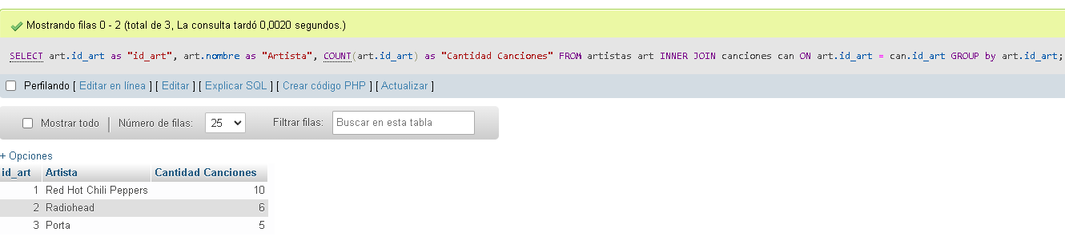

2) SELECT album, COUNT(*) as "Numero de canciones"

FROM canciones

GROUP BY album;

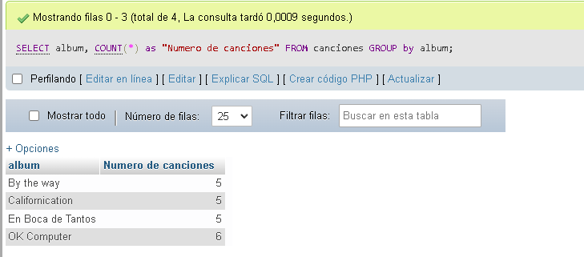

3) SELECT YEAR(fecha_lanzamiento) as "anio", Count(Year(fecha_lanzamiento)) as

"Canciones por anio", GROUP_CONCAT (cancion, " ") as "Canciones"

FROM canciones

GROUP BY Year(fecha_lanzamiento);

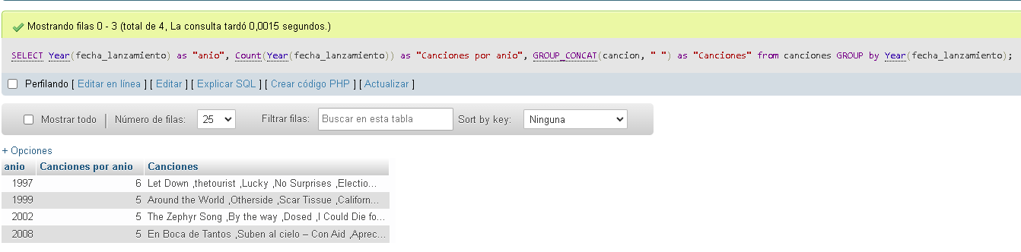

4) SELECT album, SUM(vendida*valor) as "AVG Total Recaudado", MIN(vendida*valor)

as "Valor Minimo", MAX(vendida*valor) as "Valor Maximo", ((SUM(vendida*valor))/

COUNT(cancion))AVG

FROM canciones

GROUP by album, valor ORDER BY Sum(vendida*valor) DESC;

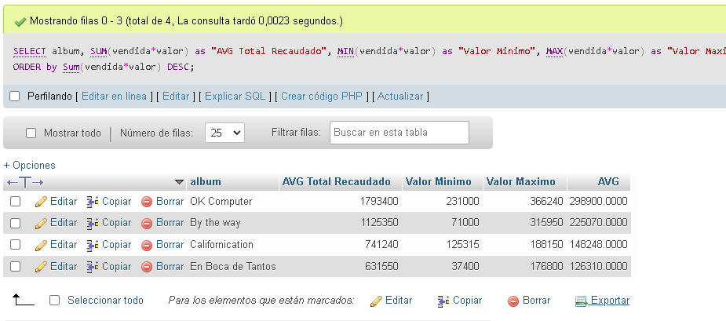

5) SELECT COUNT(DISTINCT album) as "cantidad de albumes"

FROM canciones;

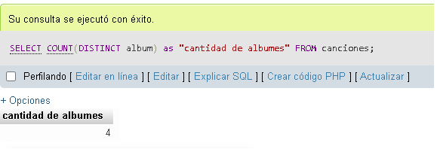

6) SELECT nombre as "Artista", can.cancion, album, fecha_lanzamiento, vendida, valor

FROM canciones can INNER JOIN artistas art on can.id_art = art.id_art

WHERE art.nombre = "Porta";

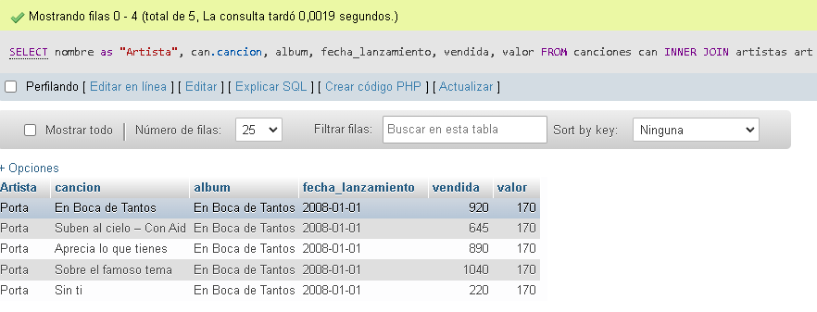

7) SELECT art.nombre, can.cancion, can.fecha_lanzamiento FROM canciones can INNER

JOIN artistas art ON can.id_art = art.id_art

WHERE YEAR(fecha_lanzamiento) > 2000;

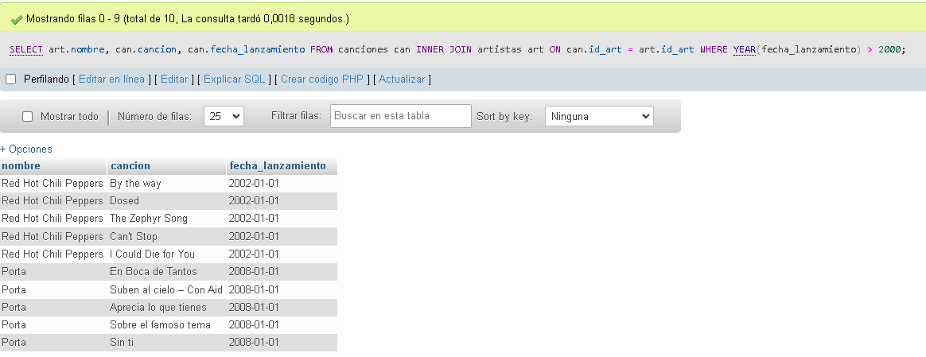

8) UPDATE canciones set vendida = (vendida)+10 WHERE id_art = 2;

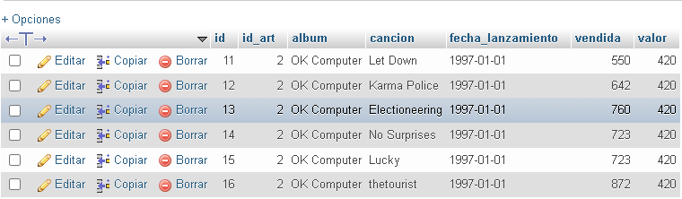

+10



9) SELECT left(album,6) AS "Album", CONCAT(cancion," ",

(YEAR(fecha_lanzamiento))) as "Cancion y Anio"

FROM canciones;

